**AI-Powered Health Assistant**

A Project Report

submitted in partial fulfillment of the requirements

of

AICTE Internship on AI: Transformative Learning

with

TechSaksham – A joint CSR initiative of Microsoft & SAP

by

**Sai Teja Ankam, ankamsaiteja27@gmail.com**

Under the Guidance of

**Jay Rathod**

**ACKNOWLEDGEMENT**

I would like to take this opportunity to express my deep sense of gratitude to all individuals who helped me directly or indirectly during this project work.

Firstly, I would like to thank my mentor, Jay Rathod, for being a great guide and providing me with invaluable insights and support throughout this project. His advice, encouragement, and constructive criticism were instrumental in shaping the project. His confidence in my abilities motivated me to push forward and successfully complete this project.

I would also like to thank my peers and the AICTE Internship program facilitators for creating an enriching learning environment. Lastly, I extend my heartfelt gratitude to my family and friends for their constant encouragement and support

#### **ABSTRACT**

This project focuses on the development of **AI-POWERED HEALTH ASSISTANT**, an AI-powered virtual assistant that provides preliminary healthcare information. The chatbot is built using **Streamlit** for the user interface and **DistilGPT2** for natural language processing. It assists users by responding to health-related queries, offering symptom-based suggestions, medication information, and emergency guidance.

The chatbot identifies emergency situations and advises users to seek immediate medical attention when necessary. The methodology involves integrating a predefined rule-based system with an AI model to generate contextual responses. The project aims to improve healthcare accessibility by providing quick and informative responses to users' queries. Future work will involve enhancing the chatbot's accuracy and integrating it with real-time healthcare databases.

**TABLE OF CONTENT**

**Abstract I**

**Table of Content II**

**Table of Figures III**

**Chapter 1.**  **Introduction 1**

1.1 Problem Statement 1

1.2 Motivation 1

1.3 Objectives 1

1.4. Scope of the Project 1

**Chapter 2.**  **Literature Survey 2**

**Chapter 3.**  **Proposed Methodology 5**

**Chapter 4.**  **Implementation and Results 9**

**Chapter 5. Discussion and Conclusion 13**

**References 15**

**LIST OF FIGURES**

|  |  |  |
| --- | --- | --- |
| **Figure No.** | **Figure Caption** | **Page No.** |
|  | System design | **5** |
|  | Landing User Interface | **9** |
|  | Asking Basic queries | **10** |
|  | Handling Emergencies | **11** |

**CHAPTER 1**

**INTRODUCTION**

* 1. **Problem Statement:**

Access to reliable and immediate healthcare advice is a significant challenge for many people. The lack of medical knowledge often leads individuals to misinterpret symptoms, causing unnecessary panic or ignorance of serious conditions. The Sia Healthcare Chatbot aims to bridge this gap by providing instant responses to common health queries and guiding users towards appropriate medical actions.

* 1. **Motivation:**

The motivation behind this project is to leverage AI and NLP to provide accessible healthcare information. Many individuals seek medical guidance online but struggle to find reliable sources. This chatbot ensures a structured and AI-assisted response to general health inquiries, reducing misinformation and improving public awareness about symptoms and medications.

* 1. **Objective:**
* Develop an AI-powered chatbot for preliminary healthcare guidance.
* Implement NLP techniques using **DistilGPT2** to generate contextual responses.
* Provide a user-friendly **Streamlit** interface for easy interaction.
* Offer symptom-based suggestions, medication details, and emergency guidance.
  1. **Scope of the Project:**

The chatbot is designed to handle common health queries and provide preliminary advice but is not a substitute for professional medical consultation. It does not diagnose conditions but guides users toward possible causes and actions. Future enhancements may include integration with real-time medical databases and voice-based interaction.

**CHAPTER 2**

**LITERATURE SURVEY**

* 1. **Review relevant literature or previous work in this domain.**

The use of artificial intelligence in healthcare has been explored extensively in recent years. AI-powered chatbots have been developed for various applications, including mental health support, preliminary diagnosis, and medical consultation assistance. Many existing healthcare chatbots rely on rule-based algorithms, which provide predefined responses based on a set of keywords. However, these systems often lack contextual understanding and flexibility when handling complex queries.

Recent advancements in natural language processing (NLP), particularly the introduction of transformer-based models like GPT-3 and BERT, have significantly improved chatbot performance. These models enable chatbots to generate more context-aware and dynamic responses, enhancing user interaction and engagement. The integration of machine learning and deep learning techniques in chatbot systems allows for more personalized healthcare recommendations.

Despite these advancements, there are challenges, including ensuring data privacy, handling medical misinformation, and improving chatbot accuracy in diagnosing symptoms. This project aims to address these limitations by combining rule-based approaches with AI-driven contextual learning to provide a more reliable and informative health assistant.

* 1. **Mention any existing models, techniques, or methodologies related to the problem.**

Various models and techniques have been utilized to develop AI-powered chatbots in healthcare. One of the most commonly used methodologies is rule-based chatbots, which rely on predefined responses to user queries. While effective for simple interactions, these chatbots struggle with complex and dynamic conversations.

Machine learning-based chatbots offer a more sophisticated alternative by utilizing natural language processing (NLP) to understand and generate responses. Transformer-based models like GPT-3, BERT, and DistilGPT2 have significantly enhanced chatbot capabilities by enabling context-aware and more natural conversations.

Hybrid models, combining rule-based and machine learning approaches, are also gaining traction. These systems use predefined rules for handling structured queries while leveraging deep learning models for contextual understanding. This ensures a balance between accuracy and flexibility, improving user experience.

Additionally, reinforcement learning techniques are being explored for chatbot optimization. These models improve over time by learning from user interactions, allowing for a more personalized and efficient healthcare assistant.

By incorporating these existing methodologies, the Sia Healthcare Chatbot effectively balances rule-based precision with AI-driven contextual learning, providing reliable and informative responses to user queries.

* 1. **Limitations in Existing models**

While AI-powered healthcare chatbots have made significant advancements, several limitations persist in existing solutions:

* Lack of Contextual Understanding: Many chatbots struggle with comprehending the full context of user queries, often providing generic or inaccurate responses. Our project integrates transformer-based NLP models to enhance contextual awareness and improve the quality of responses.
* Limited Emergency Detection: Most healthcare chatbots do not have a reliable mechanism to identify urgent medical conditions. The Sia Healthcare Chatbot addresses this by implementing an emergency detection feature that flags critical symptoms and advises users to seek immediate medical attention.
* Static Knowledge Base: Traditional rule-based chatbots rely on a fixed set of responses, limiting adaptability. By leveraging AI-driven dynamic response generation, our chatbot ensures more flexible and up-to-date interactions.
* Data Privacy Concerns: Many existing solutions raise concerns regarding the storage and handling of sensitive user data. Our project ensures data security by avoiding personal data storage and only processing queries in real-time without logging sensitive information.
* Inability to Handle Complex Queries: Some chatbots fail when users ask multi-faceted or nuanced medical questions. The Sia Healthcare Chatbot overcomes this by combining predefined responses with AI-generated contextual replies, ensuring more comprehensive answers.

**CHAPTER 3**

**PROPOSED METHODOLOGY**

* 1. **System Design**

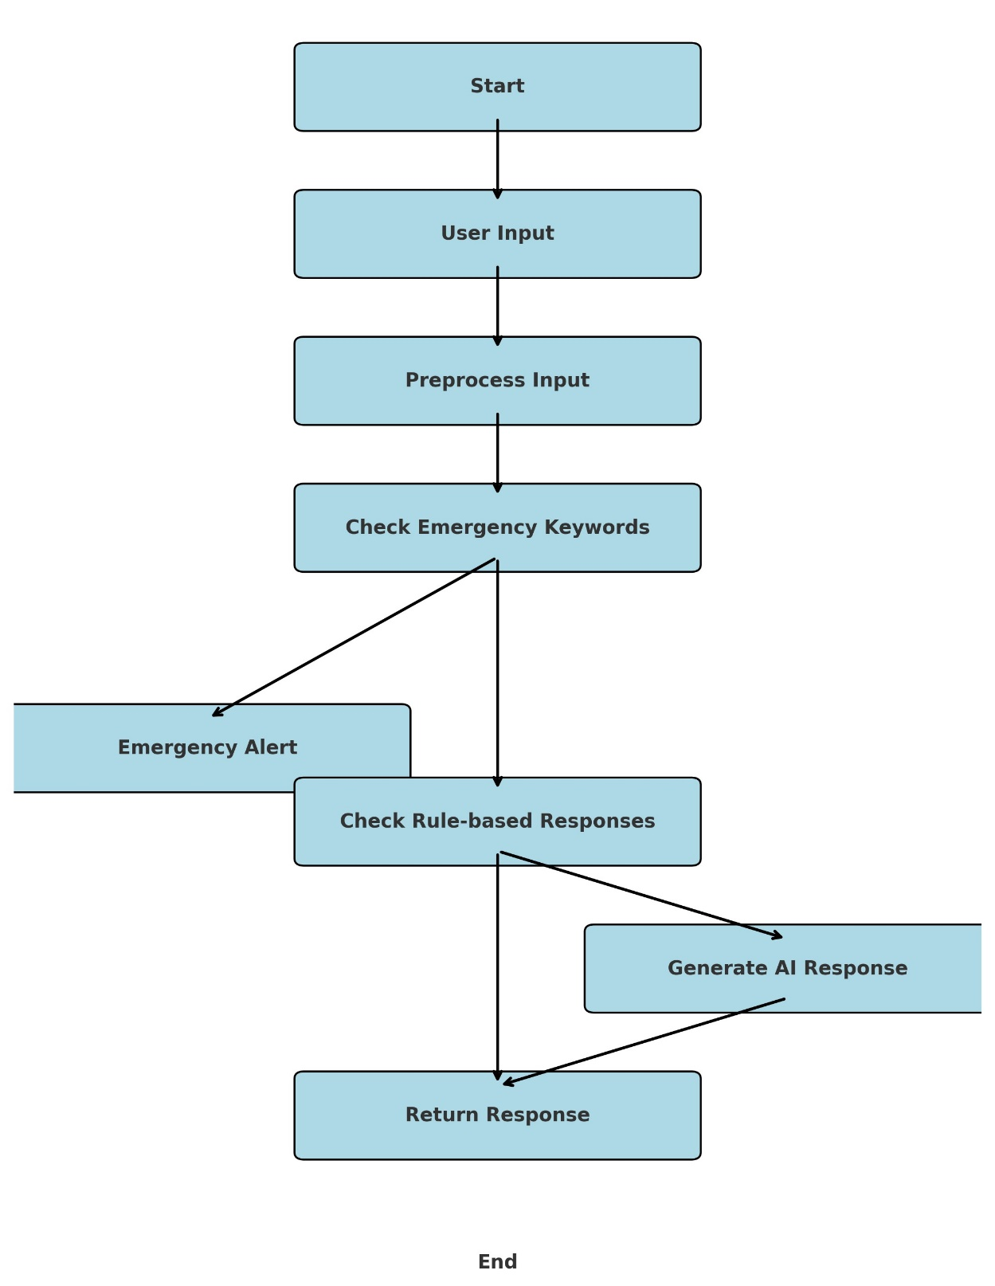

The flowchart represents the proposed solution for the Sia Healthcare Chatbot, showing the sequence of processes from user input to chatbot response generation. Here’s how each step works:

1. **Start**

The chatbot process begins when a user interacts with the system.

1. **User Input**

The user types a query related to healthcare, symptoms, or medications.

1. **Preprocess Input**

The chatbot processes the input by cleaning the text and identifying key terms using Natural Language Processing (NLP).

1. **Check Emergency Keywords**

The system scans the input for emergency keywords (e.g., "chest pain", "severe bleeding", "difficulty breathing").

If an emergency is detected, it directs the user to seek immediate medical help.

1. **Emergency Alert (If detected)**

If the chatbot identifies an emergency case, it immediately alerts the user to contact local emergency services.

The chatbot ends the conversation at this point to avoid providing misleading advice for critical conditions.

1. **Check Rule-based Responses**

If there’s no emergency, the chatbot checks for predefined rule-based responses related to common symptoms (e.g., headache, fever) and medications.

If a relevant response exists, it is directly sent to the user.

1. **Generate AI Response (If no rule-based match)**

If the chatbot does not find a predefined response, it uses a machine learning model (DistilGPT2) to generate an AI-based response.

This ensures dynamic and context-aware interactions.

1. **Return Response**

The final response (from either rule-based matching or AI generation) is sent back to the user in a conversational format.

1. **End**

The chatbot session ends once the response is delivered.

* 1. **Requirement Specification**
     1. **Hardware Requirements:**

To efficiently implement and run the Sia Healthcare Chatbot, the following hardware requirements must be met:

**Processor**: Intel i5 (8th Gen or above) / AMD Ryzen 5 or equivalent.

**RAM**: Minimum 8GB (16GB recommended for optimal performance).

**Storage**: At least 20GB of free disk space for model storage and execution.

**Graphics** **Card**: Not mandatory but a dedicated GPU (NVIDIA GTX 1060 or better) can accelerate model inference.

**Internet** **Connectivity**: Required for fetching external healthcare resources and updating AI models.

**Operating** **System**: Windows 10/11, macOS, or Linux-based distributions (Ubuntu recommended).

These hardware requirements ensure smooth execution of the NLP model, real-time response generation, and efficient user interactions within the chatbot interface.

* + 1. **Software Requirements:**

The following software components are required for the **Sia Healthcare Chatbot**:

* **Operating System**: Compatible with Windows, macOS, and Linux (Ubuntu recommended).
* **Programming Language**: Python 3.8 or later.
* **Frameworks & Libraries**:
  + **Streamlit**: For developing the chatbot's web interface.
  + **Transformers (Hugging Face)**: For implementing the DistilGPT2 NLP model.
  + **PyTorch/TensorFlow**: For deep learning-based text processing.
  + **Regex**: For keyword detection in user queries.
  + **Requests**: For API calls to fetch external healthcare information.
* **Development Tools**:
  + **Jupyter Notebook / VS Code / PyCharm**: For coding and debugging.
  + **GitHub**: For version control and collaboration.
* **Database (Optional)**:
  + **SQLite / PostgreSQL**: If future versions require storing user interactions for learning improvements.

These software requirements ensure the chatbot is built with robust, scalable, and easily maintainable technologies, enabling efficient performance and accurate responses.

**CHAPTER 4**

**Implementation and Result**

* 1. **Snap Shots of Result:**

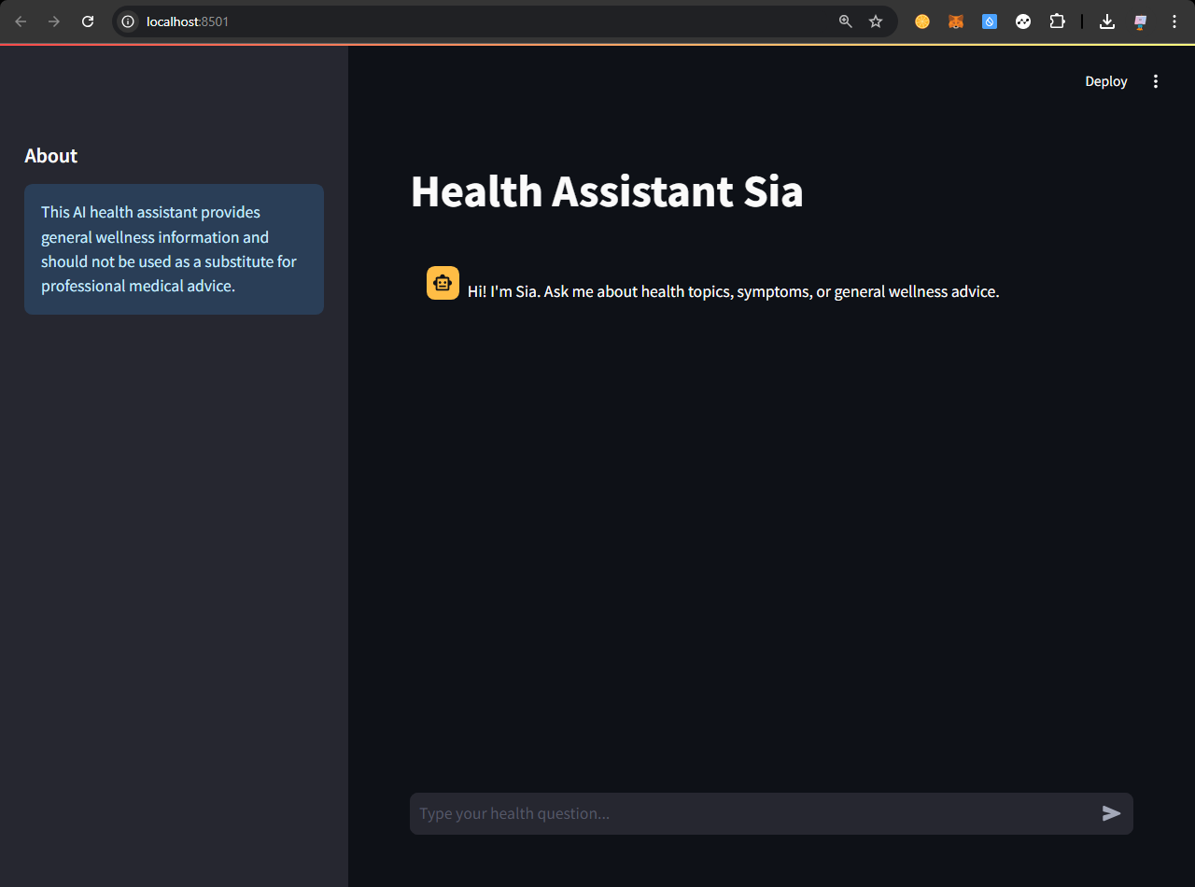

**Figure-1: Landing user interface**

After running the `streamlit run main.py` it will redirect to this landing page where is you can ask queries and basic medication details

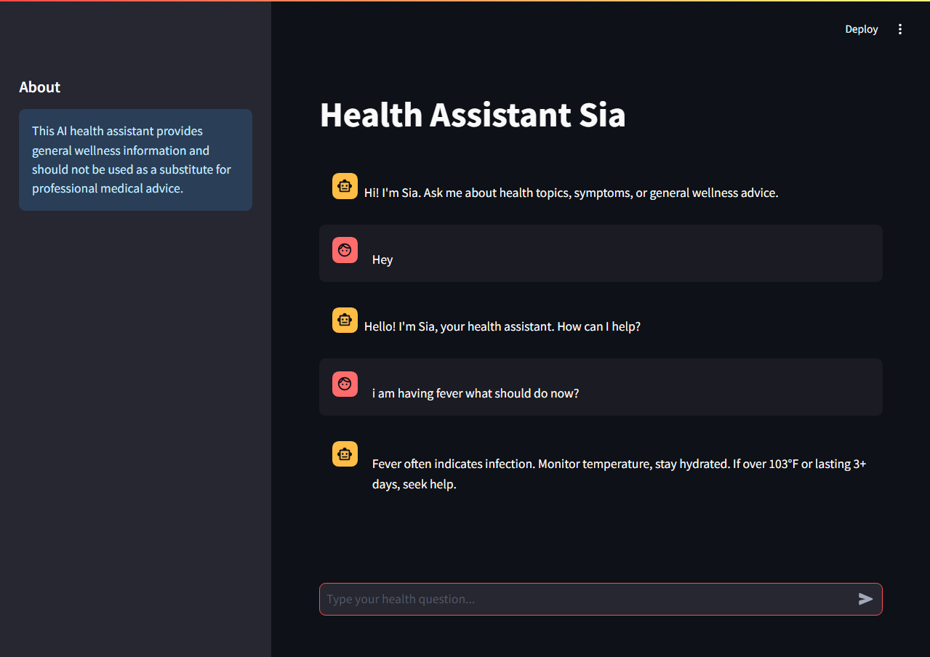

**Figure-2: Asking basic queries**

It can handle basic greetings and basic symptoms (here we ask a query to the bot and replies as stay hydrated, Monitor temperature..etc.)

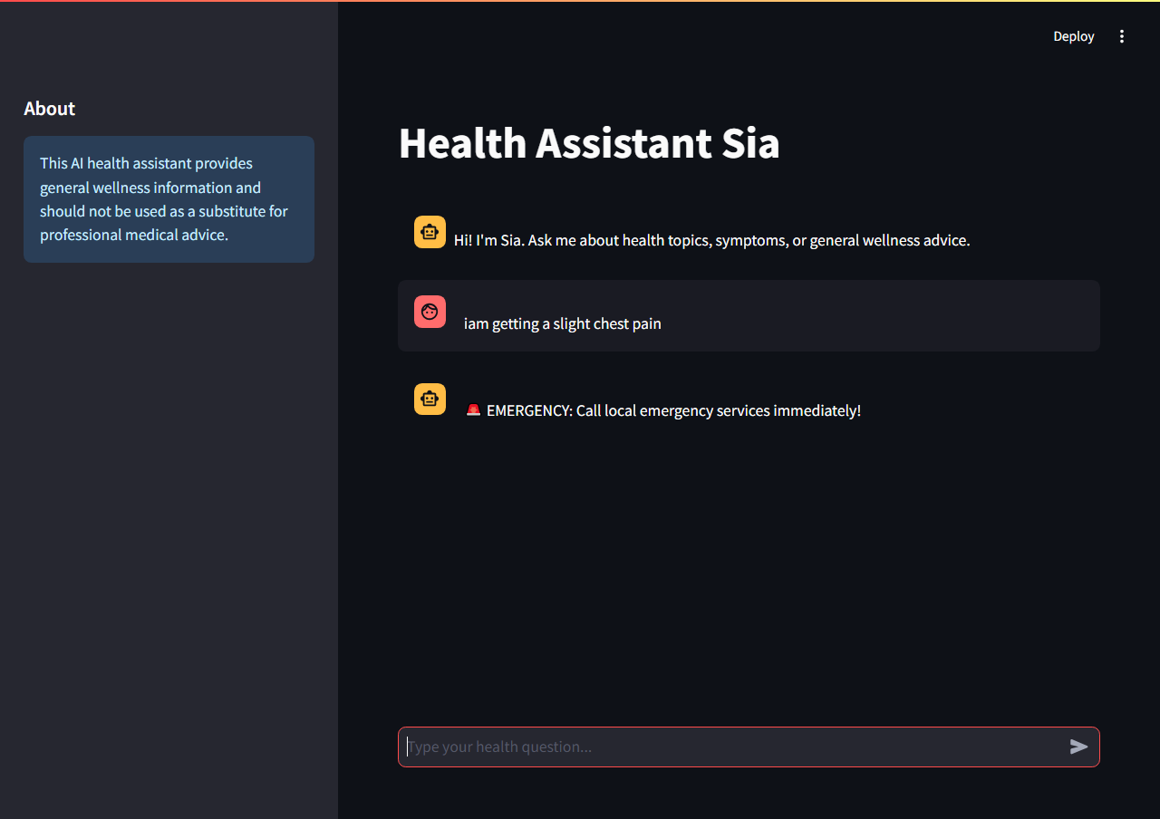

**Figure-3: Handling emergencies**

The queries related to serious symptoms will warn you to visit doctor to get you heal immediately

* 1. **GitHub Link for Code:**

<https://github.com/saitej-a/Techsaksham.git>

**CHAPTER 5**

**Discussion and Conclusion**

* 1. **Future Work:**

Although the **Sia Healthcare Chatbot** effectively provides preliminary medical guidance, there are several areas for future improvements:

1. **Enhanced NLP Model Fine-tuning**: Future iterations of the chatbot can integrate **fine-tuned medical AI models** trained on larger healthcare-specific datasets to improve accuracy.
2. **Multilingual Support**: Expanding language support will make the chatbot more accessible to a **wider audience** across different regions.
3. **Integration with Electronic Health Records (EHRs)**: Future work may involve linking the chatbot with **EHR systems** to provide more personalized and relevant health recommendations.
4. **Voice-based Interaction**: Implementing **speech-to-text and text-to-speech** features will enable users to interact with the chatbot through voice commands, enhancing usability.
5. **Real-time Medical Updates**: Incorporating a mechanism to fetch **real-time medical news and updates** from trusted healthcare sources will ensure the chatbot remains up-to-date.
6. **Improved Emergency Handling**: Enhancing emergency detection capabilities and integrating a **location-based service** for nearby hospital suggestions will increase the chatbot’s effectiveness in urgent situations.
7. **User Feedback and Adaptive Learning**: Implementing **continuous learning mechanisms** where the chatbot adapts based on user feedback will further improve response quality over time.

These enhancements will make the chatbot more **intelligent, versatile, and user-friendly**, ensuring it remains a valuable tool in the healthcare sector.

* 1. **Conclusion:**

The Sia Healthcare Chatbot successfully demonstrates the potential of AI-driven conversational agents in providing preliminary healthcare assistance. By integrating Natural Language Processing (NLP) models such as DistilGPT2, the chatbot delivers contextual and informative responses to users' health-related queries. The hybrid approach of combining rule-based responses with AI-generated answers ensures both accuracy and adaptability in handling diverse medical inquiries.

One of the key achievements of this project is its emergency detection capability, which guides users to seek immediate medical attention when necessary. Additionally, the chatbot ensures data privacy and security by not storing personal user information, making it a safe and reliable tool for healthcare guidance.

While the chatbot significantly improves accessibility to basic healthcare information, it is not a substitute for professional medical consultation. Future advancements, including multilingual support, voice-based interaction, real-time medical updates, and integration with Electronic Health Records (EHRs), can further enhance its effectiveness and usability.

In conclusion, the Sia Healthcare Chatbot represents a valuable step forward in AI-assisted healthcare support, helping bridge the gap between users and essential health information while maintaining safety, reliability, and continuous learning capabilities.

**REFERENCES**

1. Although the Sia Healthcare Chatbot effectively provides preliminary medical guidance, there are several areas for future improvements:
2. Enhanced NLP Model Fine-tuning: Future iterations of the chatbot can integrate fine-tuned medical AI models trained on larger healthcare-specific datasets to improve accuracy.
3. Multilingual Support: Expanding language support will make the chatbot more accessible to a wider audience across different regions.
4. Integration with Electronic Health Records (EHRs): Future work may involve linking the chatbot with EHR systems to provide more personalized and relevant health recommendations.
5. Voice-based Interaction: Implementing speech-to-text and text-to-speech features will enable users to interact with the chatbot through voice commands, enhancing usability.
6. Real-time Medical Updates: Incorporating a mechanism to fetch real-time medical news and updates from trusted healthcare sources will ensure the chatbot remains up-to-date.
7. Improved Emergency Handling: Enhancing emergency detection capabilities and integrating a location-based service for nearby hospital suggestions will increase the chatbot’s effectiveness in urgent situations.
8. User Feedback and Adaptive Learning: Implementing continuous learning mechanisms where the chatbot adapts based on user feedback will further improve response quality over time.
9. These enhancements will make the chatbot more intelligent, versatile, and user-friendly, ensuring it remains a valuable tool in the healthcare sector.